

INDIVIDUAL ASSIGNMENT

[**COMP40004-K-1**](https://lms.apiit.lk/course/view.php?id=2079)

**WEB DEVELOPMENT AND OPERATING SYSTEMS-1**

**ASSIGNMENT-2**

**Name- Lasini Minsarini Dissanayake**

**CB NO- CB012167  
  
Batch Code- CFK2321COM  
  
Level- 04  
  
Draft Hand In Date- 11th May 2023  
  
Lecturer- Ms. Valuka** **Wijayagunawardene  
  
Assignment- Create a Web Application for a Turtle Hatcheries Website**

**Acknowledgment**

I would like to express my special thanks of gratitude to my lecturer Ms.Valuka Wijayagunawardene for her guidance and support in doing the assignment.

I would also like to extend my gratitude to my friends and batch mates who helped me when I needed it.

**Table of Contents**

1. Introduction
2. Wireframes for Desktop version
3. Wireframes for the Mobile version
4. Link to Web Application
5. Conclusion
6. References

**Introduction**

This web application is about “Turtle Hatcheries is Sri Lanka”. The main reason to create this web application is to create awareness about turtle hatcheries. This report contains detailed wireframes of the created website. This web application has 8 pages including home page, categories page, Hikkaduwa page, Threats page, Purchase and Donations page.

Wireframes connect the site’s information architecture to its visual design by showing paths.

**Wireframes for Desktop version**  
  
  
**All the Desktop Wireframes**  
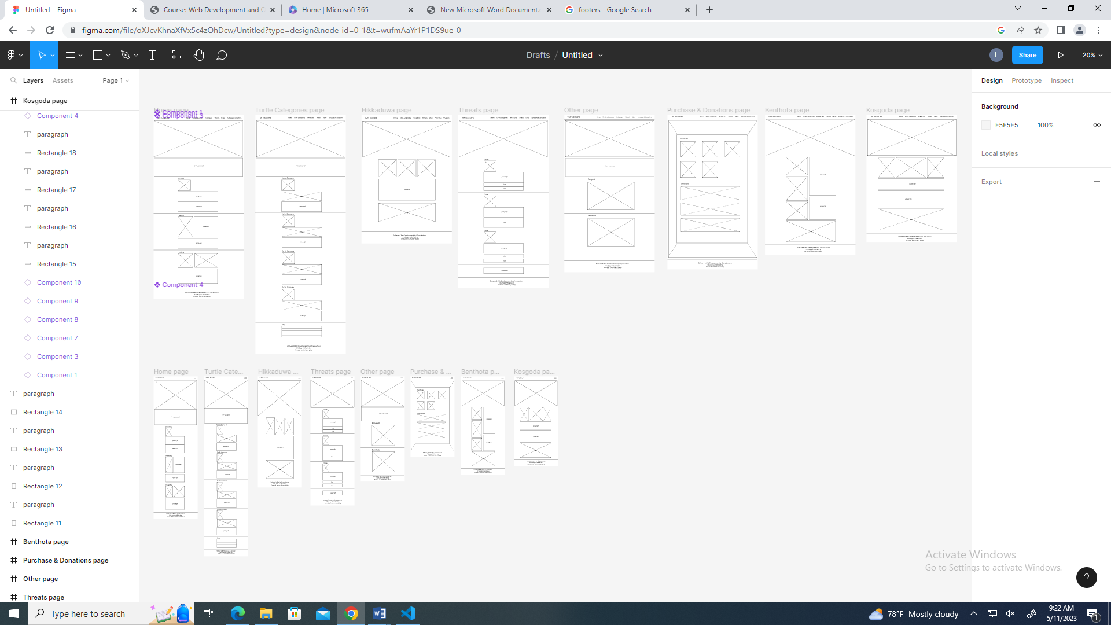

Figure 1

**Home page**

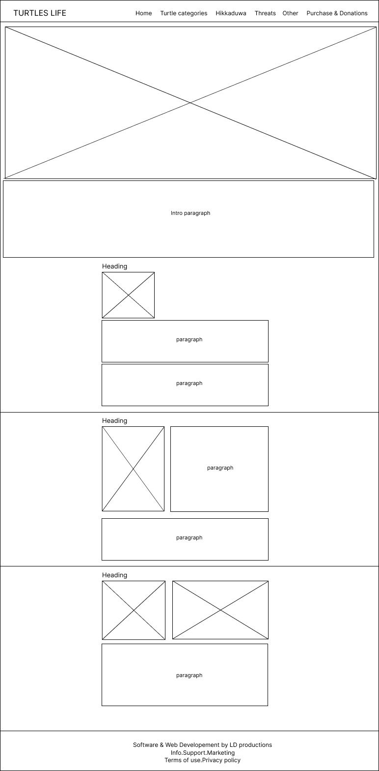

Figure 2

**Turtle Categories page**

*Figure 3*

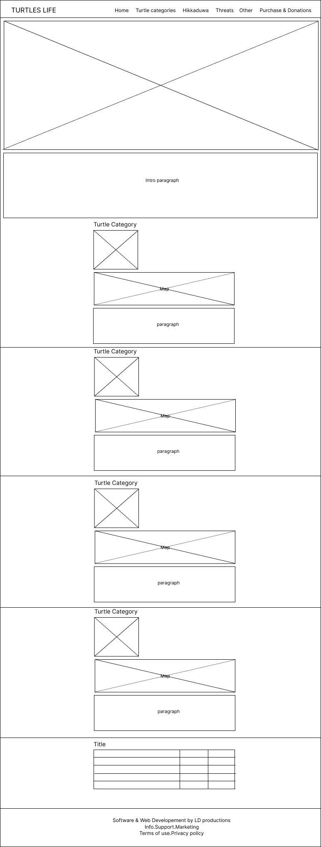

**Hikkaduwa page**

*Figure 4*

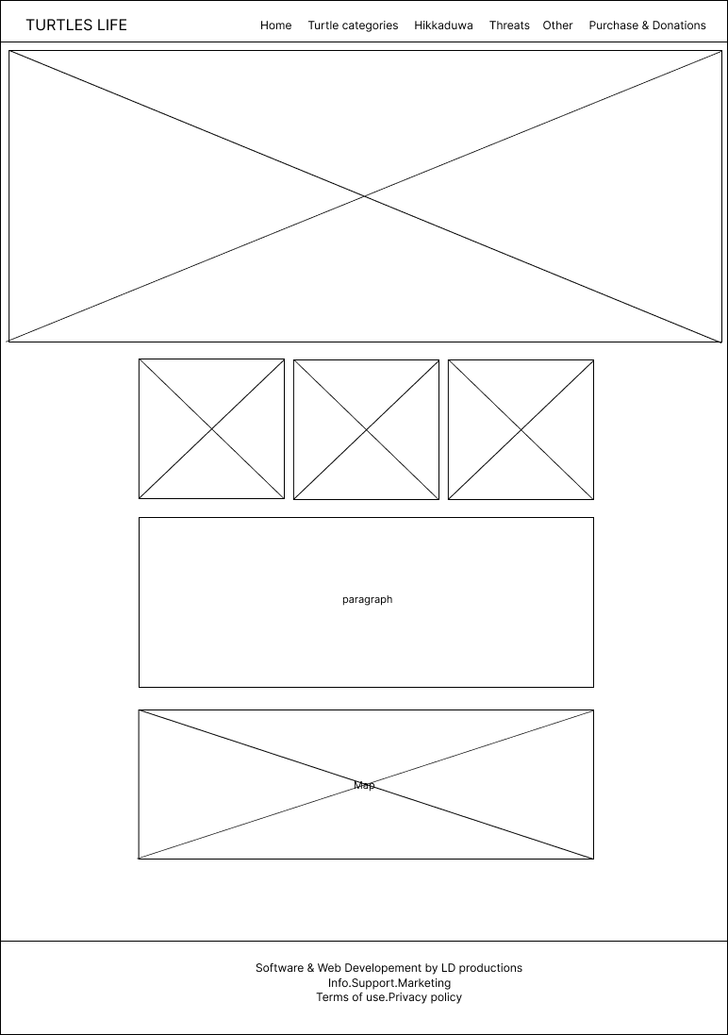

**Threats page**

*Figure 5*

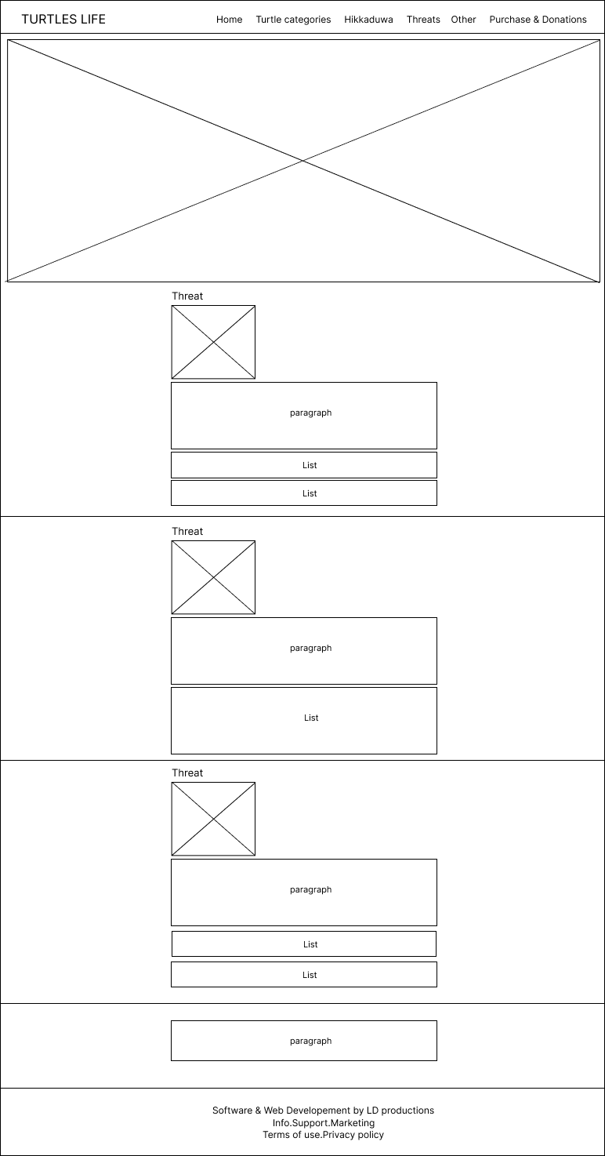

**Other page**

*Figure 6*

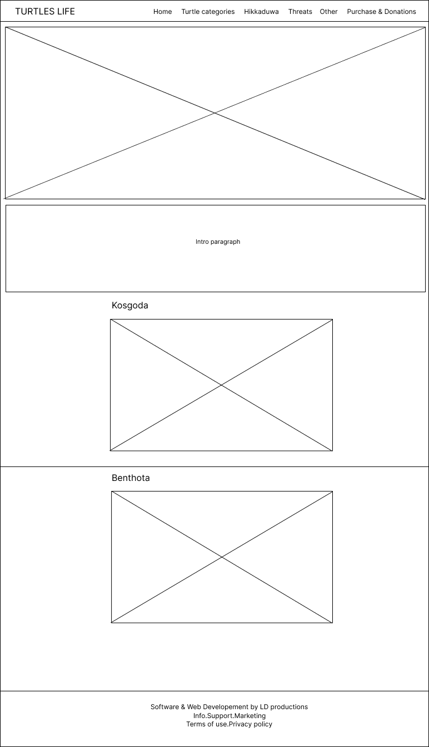

**Purchase and Donations page**

*Figure 7*

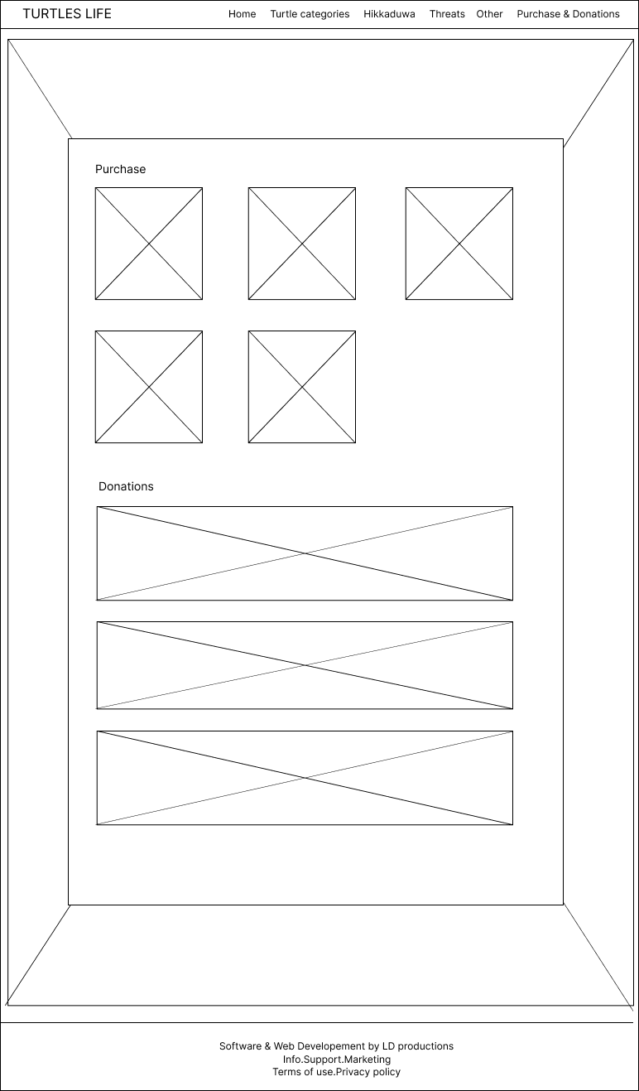

**Benthota page**

*Figure 8*

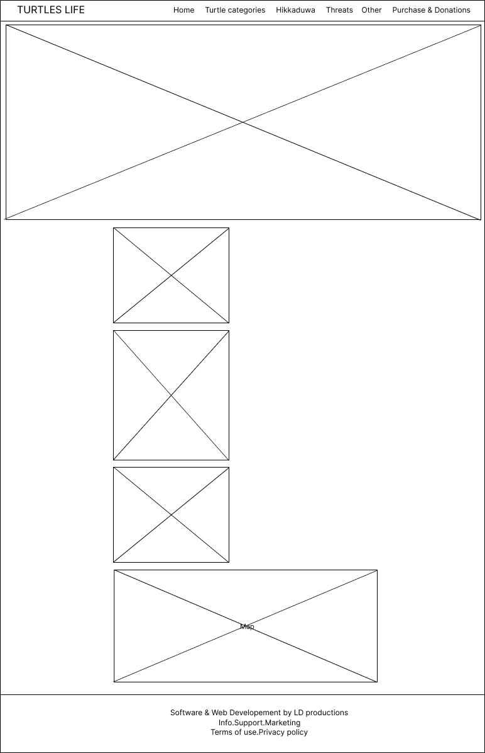

**Kosgoda page**

**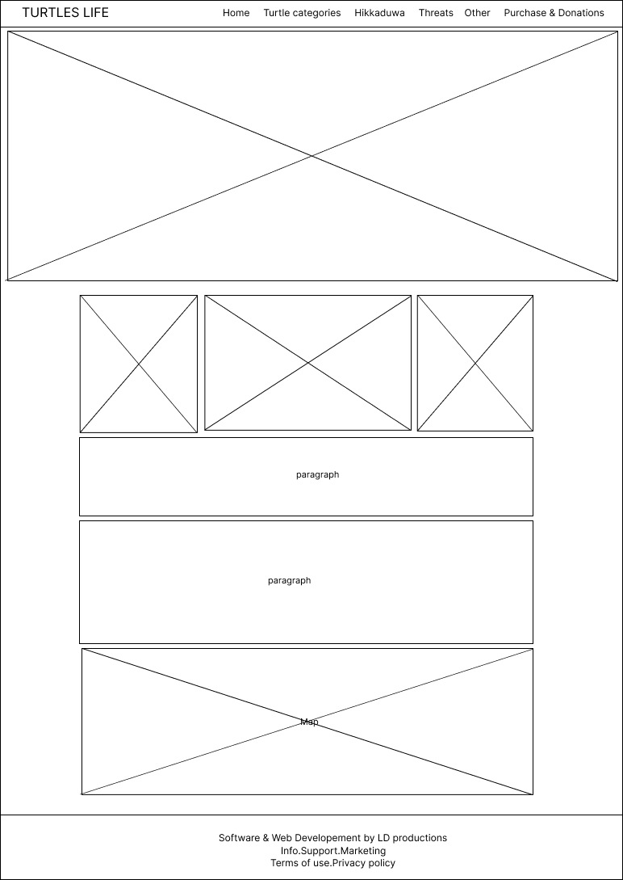***Figure 9*

**Wireframes for mobile version**

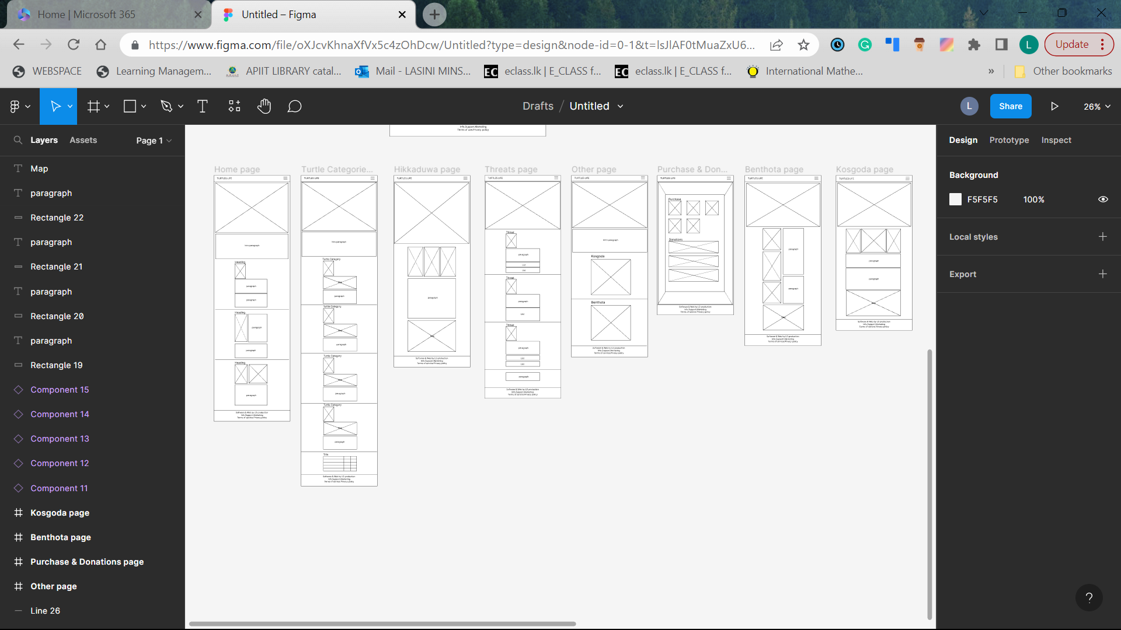*Figure 10*

**Home page**

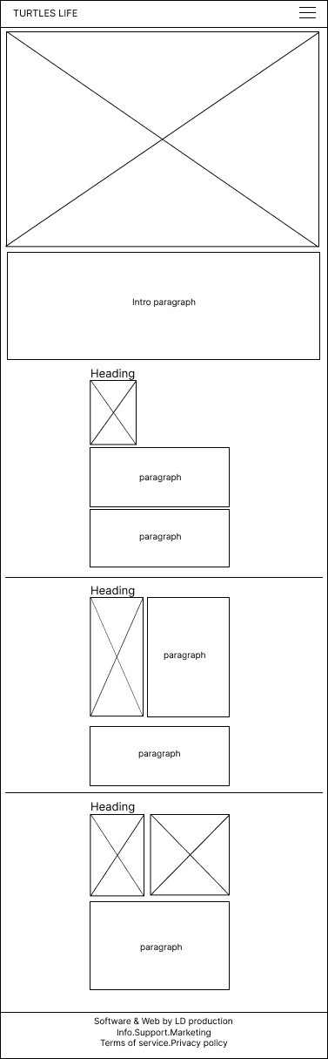

Figure 11

**Turtle categories page**

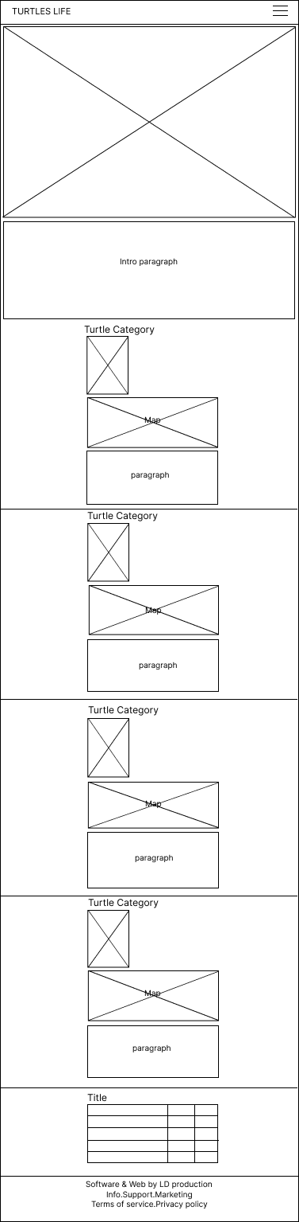  
*Figure 12*

**Hikkaduwa page**

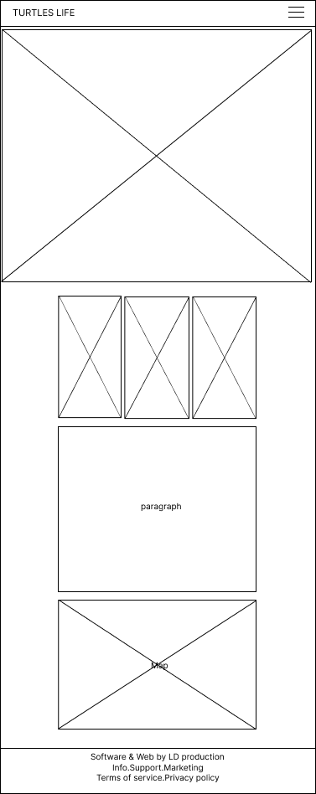

Figure

**Threats page**

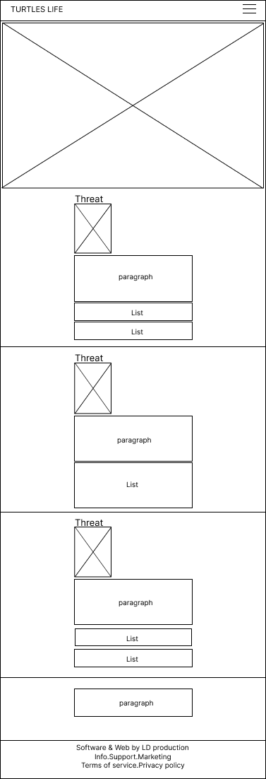

Figure

**Other page**

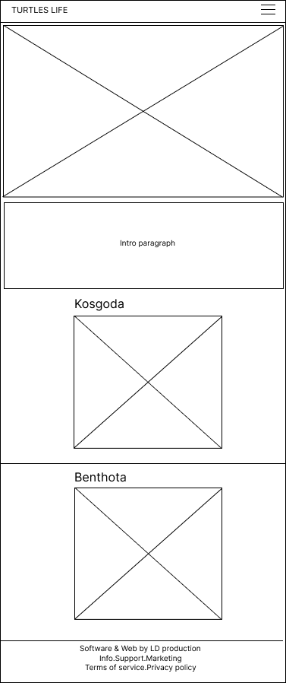

Figure

**Purchase and Donations page**

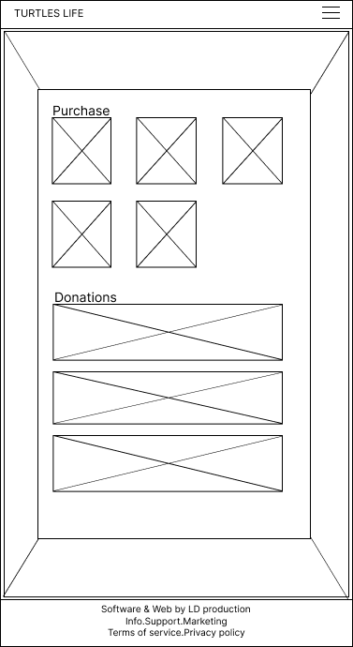

Figure

**Benthota page**

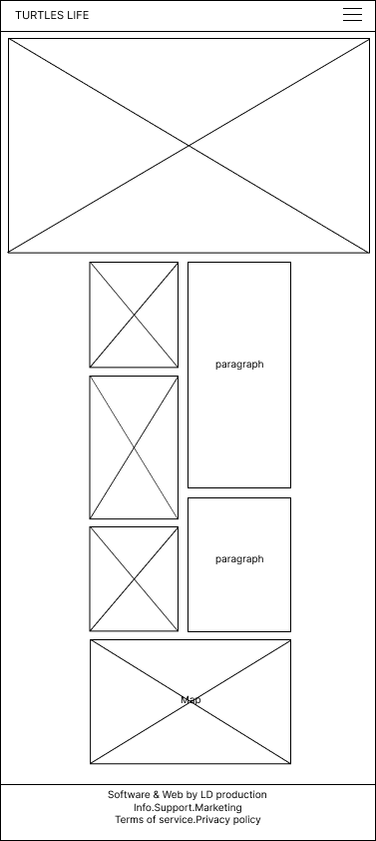

Figure

**Kosgoda page**

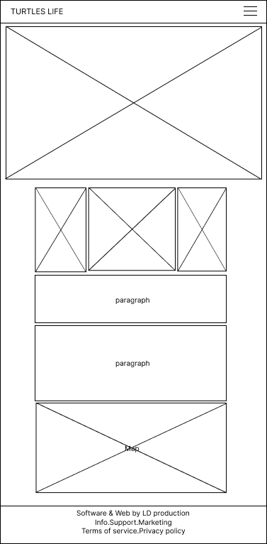

Figure

**Link to Web Application**

**Conclusion**

The first Assignment we have for WDOS is the turtle hatcheries website, and this report was used to document the wireframes created for that website. To conclude this report I would like to say that the above information is true and that it is all my own work.

**References**  
  
Wireframes making app- Figma (https://www.figma.com/login)